Notes:

When you want to get number of probabilities where (Heads == Tails) in 2-coin flips

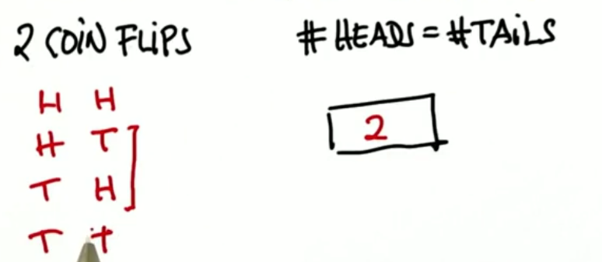H H – H T – T H – T T

When you want to get number of probabilities where (Heads == Tails) in 4-coin flips

You have to create truth table for it.

|  |  |  |  |
| --- | --- | --- | --- |
| First flip | Second flip | Third flip | Fourth flip |
| H | H | H | H |
| T |
| T | H |
| T |
| T | H | H |
| T |
| T  T | H |
| T |
| T | H | H | H |
| T |
| T | H |
| T |
| T | H | H |
| T |
| T | H |
| T |

When you want to get number of probabilities where (Heads == Tails) in an odd number of-coin flips

It is always zero

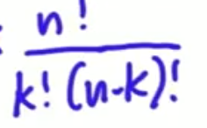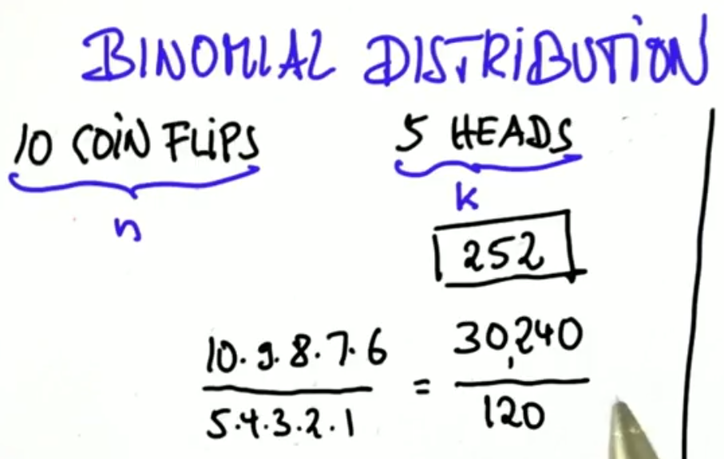

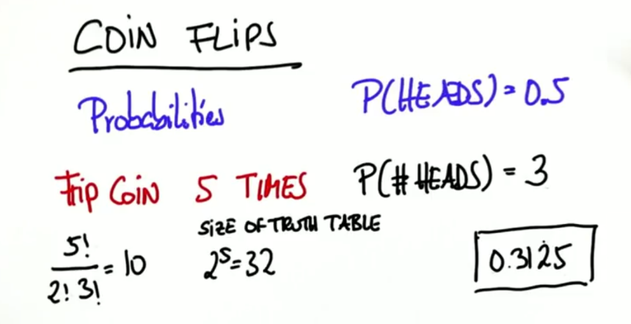

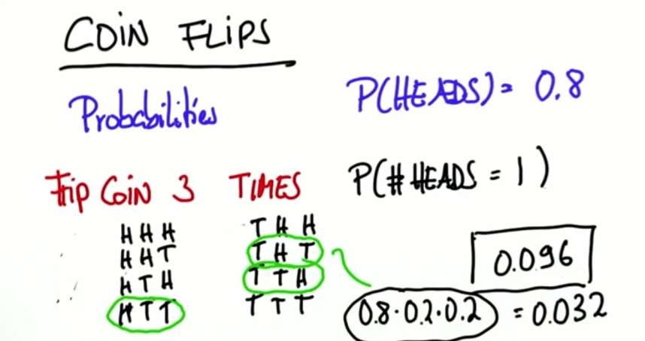Note that in a un-biased coin

The probability of a value in truth table is (1/8) which is

(1/size of truth table) and also is

(0.5 * 0.5 * 0.5)

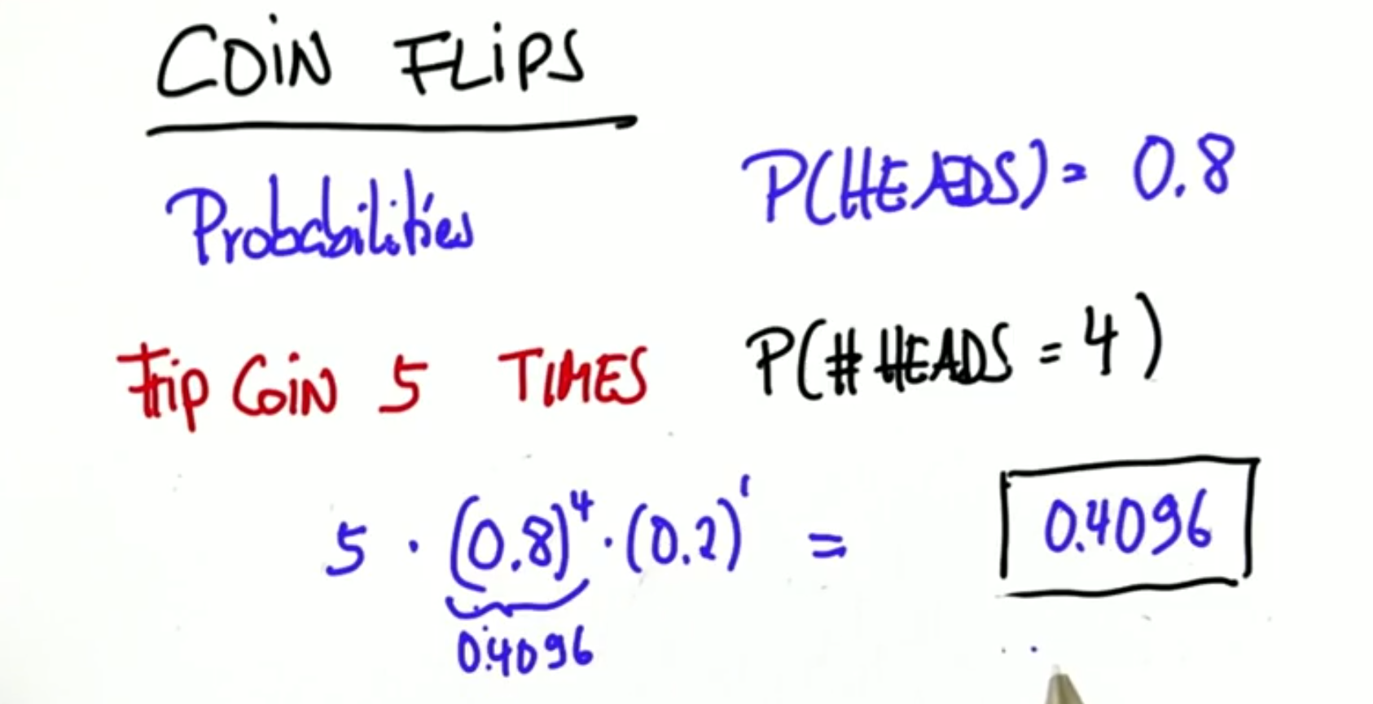

Summary

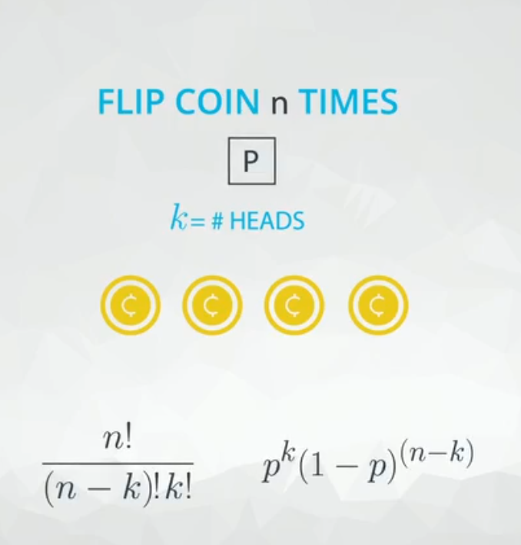for this law, it calculates the possible number of ways in which we can get k in n times of coin flips

for this law

Pk tracks probability of k and (1-P)(n-k) tracks the probability of the other term (in an unbiased coin these terms cancel each other )

And the final and complete law is (Binominal Distribution):

